Wet & Dry Waste Separation System

OVERVIEW:
This project focuses on automatically separating wet and dry waste. It aims to improve waste management and promote environmental sustainability. The system sorts trash into appropriate categories with minimal human effort. It encourages proper disposal habits and reduces landfill pollution. Overall, it supports a cleaner and greener community. Here’s the circuit of the project.

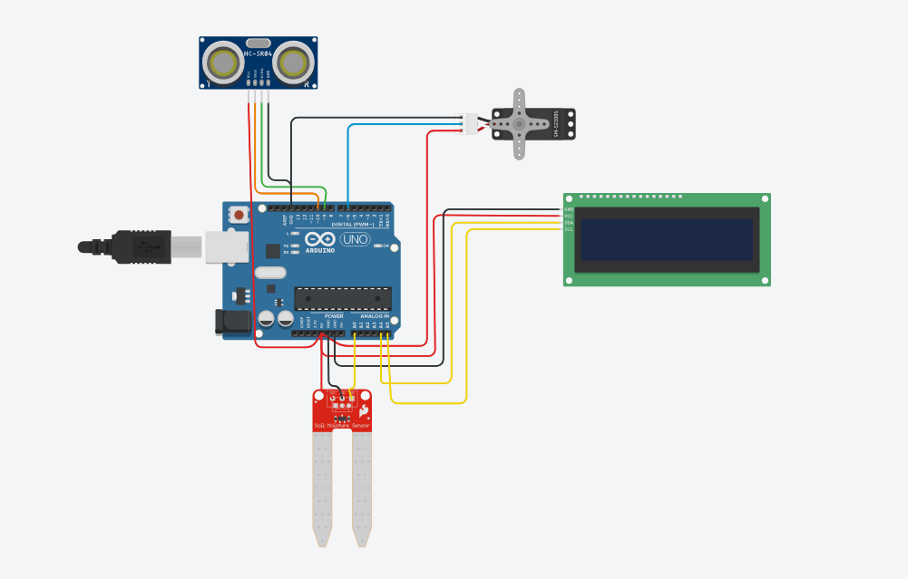

COMPONENTS:

• Arduino UNO
Purpose: Acts as the brain of the project. It processes data from sensors and controls outputs (like motors and displays).
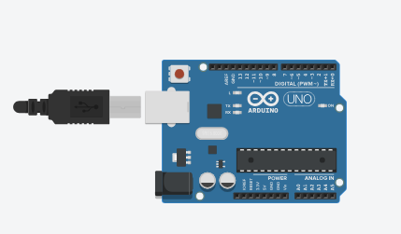

• Soil Moisture Sensor
Purpose: Detects moisture content in the waste to help differentiate between wet and dry trash.

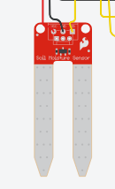
• Ultrasonic Sensor (HC-SR04)
Purpose: Detects the presence or distance of waste. Often used to check if trash is approaching the system.
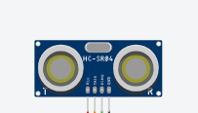
• Servo Motor
Purpose: Rotates or moves a flap to direct the trash into the correct bin (wet or dry).
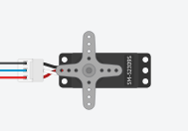
• LCD Display (16x2)
Purpose: Displays system status, such as “Wet Waste Detected” or “Dry Waste Sorted”.
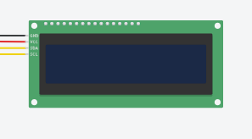

• Jumper Wires
Purpose: Used to connect all electronic components to the Arduino board.

Working Overview
This project is designed to automatically detect, identify, and sort wet and dry waste using sensors and a servo motor mechanism. When an object (trash) comes close to the system, the ultrasonic sensor detects its presence based on distance measurement. Once detected, the soil moisture sensor evaluates the moisture level of the waste.
- If moisture is high, the system classifies the trash as wet waste and moves the servo arm to the left, dropping it into the wet bin.
- If moisture is low, it is classified as dry waste, and the servo rotates to the right, dropping it into the dry bin.
Throughout the process, the LCD screen displays the system’s current status such as:
- "Trash Detected"
- "Wet Waste" or "Dry Waste"
- Default screen: “Wet and Dry Segregator”
After sorting, the servo returns to the center position, ready for the next piece of trash. This setup reduces manual waste sorting and encourages environmentally responsible disposal.

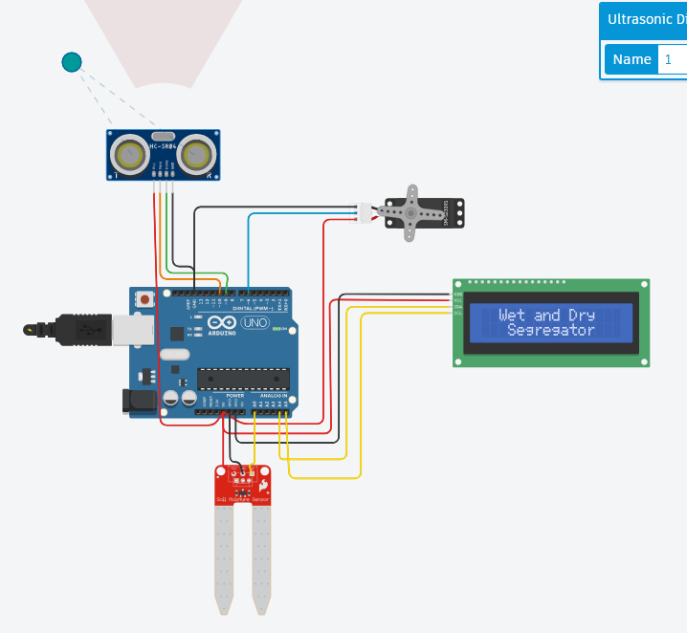
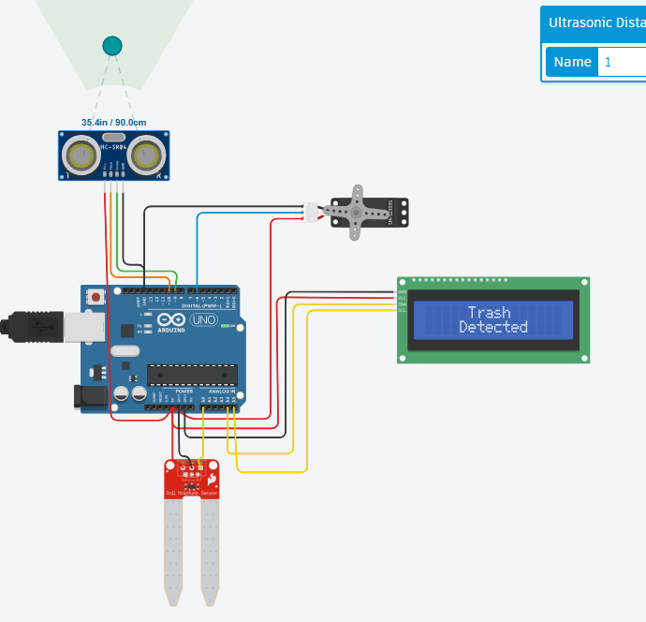

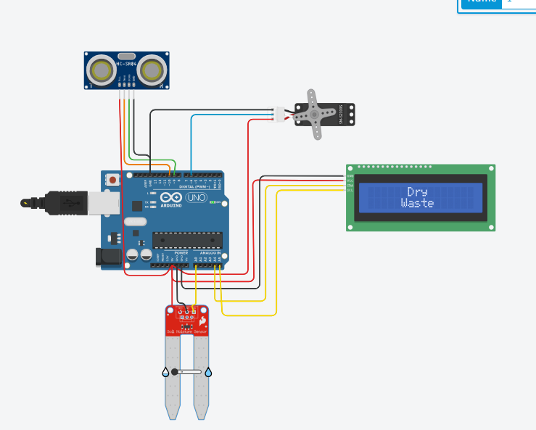
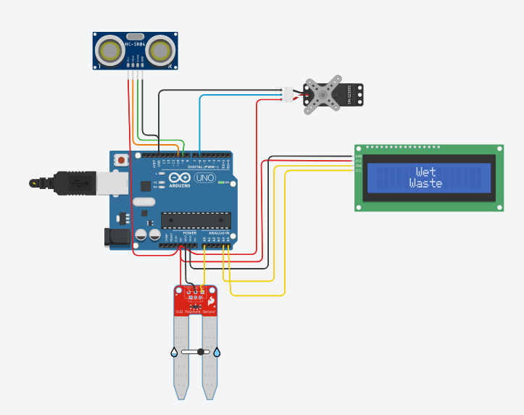

CODE:
#include <Servo.h>
#include <Wire.h>
#include <LiquidCrystal_I2C.h>

const int soilSensorPin = A0;
const int TrigPin = 10; // HC-SR04 Trig pin
const int EchoPin = 9; // HC-SR04 Echo pin
const int servoMotorPin = 6;

LiquidCrystal_I2C lcd(0x27, 16, 2);
Servo servoMotor;

void setup() {
Serial.begin(9600);
lcd.init();
lcd.backlight();

pinMode(TrigPin, OUTPUT);
pinMode(EchoPin, INPUT);

servoMotor.attach(servoMotorPin);
slideToCenter();
}

void loop() {
int soilMoisture = analogRead(soilSensorPin);
float distance = getUltrasonicDistance();
float thresholdDistance = 100.0; // cm — increase range for easier triggering

Serial.print("Distance: ");
Serial.print(distance);
Serial.println(" cm");

Serial.print("Soil Moisture: ");
Serial.println(soilMoisture);

if (distance > 0 && distance <= thresholdDistance) {
Serial.println("Trash detected");
lcd.clear();
lcd.setCursor(5, 0);
lcd.print("Trash");
lcd.setCursor(4, 1);
lcd.print("Detected");
delay(1500);

if (soilMoisture > 512) {
// Wet Waste: Low value = more moisture
lcd.clear();
lcd.setCursor(6, 0);
lcd.print("Wet");
lcd.setCursor(5, 1);
lcd.print("Waste");
slideToLeft();
delay(1000);
slideToCenter();
Serial.println("Wet - Moved left");
} else {
// Dry Waste: High value = less moisture
lcd.clear();
lcd.setCursor(6, 0);
lcd.print("Dry");
lcd.setCursor(5, 1);
lcd.print("Waste");
slideToRight();
delay(1000);
slideToCenter();
Serial.println("Dry - Moved right");
}
} else {
Serial.println("No trash detected");
lcd.clear();
lcd.setCursor(2, 0);
lcd.print("Wet and Dry");
lcd.setCursor(2, 1);
lcd.print(" Segregator");
}

delay(500);
}

float getUltrasonicDistance() {
digitalWrite(TrigPin, LOW);
delayMicroseconds(2);
digitalWrite(TrigPin, HIGH);
delayMicroseconds(10);
digitalWrite(TrigPin, LOW);

long duration = pulseIn(EchoPin, HIGH, 30000); // 30ms timeout
if (duration == 0) return 0;

float distance_cm = duration * 0.0343 / 2.0;
return distance_cm;
}

void slideToCenter() {
servoMotor.write(97);
}

void slideToLeft() {
for (int pos = 97; pos >= 7; pos--) {
servoMotor.write(pos);
delay(10);
}
}

void slideToRight() {
for (int pos = 97; pos <= 187; pos++) {
servoMotor.write(pos);
delay(10);
}
}

